 | Name: ________________________  Mathematics Essential  Test 9, 2015  Topics – Analysing and Interpreting Data. |  | 43  =
Total Time: | 60 minutes
Total Reading: | 5 minutes
Total Working: | 55 minutes
Weighting: | 4 percent
Equipment Allowed: | Calculator, 1 page of A4 notes.
You must include all working out to receive full marks

CALCULATOR FREE
- [4 marks: 1/2 each]
Use the following words to complete the sentences below:
Quartile Mean Mode Deciles Range Percentiles Spread
Standard Deviation Median Average Outliers Frequency Interquartile

a) The is calculated by adding all the scores and dividing by the number of scores. This is what most people call the .

b) In Statistics, are the data values that are very different from other measurements in the data set.

c) If we divide the data into tenths, they are called .

If we divide the data into quarters, they are called .

If we divide the data into hundredths, they are called .

d) The ________________________ is used to measure the spread of data, like the range
and the range.

2. [4 marks: 1, 1, 1, 1]
For the data below find the following;
2, 4, 2, 3, 8, 2, 7,

a) mean _______________

b) median _______________

c) mode _______________
3. [2 Marks: 1 each]
Dianna records the points scored by the players in an indoor cricket competition and displays them in the following graph.

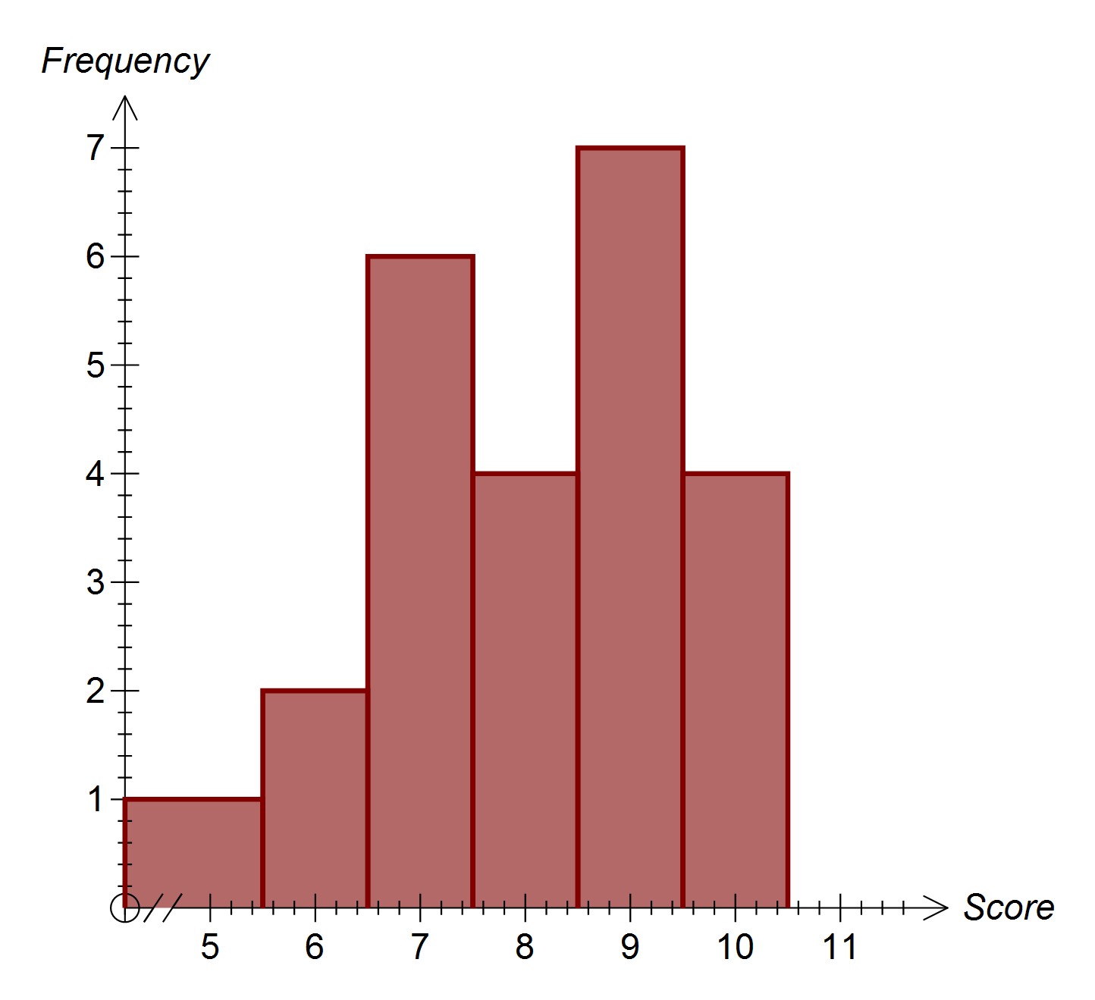

- What is the modal score?

- What is the range in scores?

4. [ 5 marks, 1, 1, 1, 2]
The following data shows the daily maximum temperatures (in °C) for 7 days in Perth in December.

31, 27, 27, 30, 25, 31, 31
For this data;
- What is the median?

- What is the lower Quartile?

- What is the upper Quartile?

- What is the Interquartile range?

5. [2 marks]
This stem-and-leaf plot refers to the Runs Scored by members of a T20 Cricket Team. Describe the spread of scores shown in this data.

Stem | Leaf
0 | 3 | 4 | 5 | 6 | 8
1 | 3 | 4 | 5 | 6 | 7 | 9
2 | 0 | 0 | 3 | 3 | 7 | 8 | 9
3 | 6 | 8 | 9 | 9
4 | 0 | 0 | 0 | 5 | 7
5 | 0 | 5 | 7
6 | 3

6. [5 marks, 1, 1, 1, 2]
The graph below is the boys length for age percentiles chart from birth to 24months.
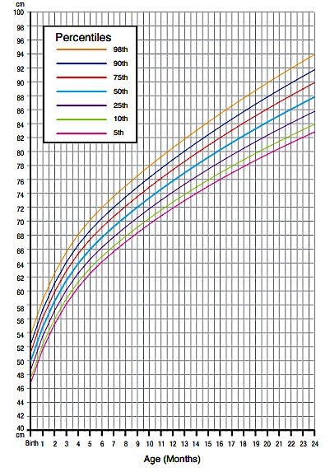

10th
25th
75th
50th
90th
98th
5th
- What length should a 9 month old boy be according to the 50th percentile?

- What age should a 72 cm length boy be according to the 5th percentile?

- What is the median length for a boy of 22 months?

- If a baby was 24months old and was 92cm long, what percentage of boys were longer?

Name……………………………………… Date………………………..

CALCULATOR ASSUMED

7. [5 marks, 1, 1, 3]
The suburb of Baldivis has 6 properties for sale. The prices are:
$498 750, $473 500, $515 000, $989 999, $478 950, $484 500,

a) What is the mean price for the houses?
b) Find the median price of the houses.
c) Is there an outlier in the price of the properties? If so, does this effect the mean and/ or median. Justify your answer.
8. [3 marks, 2, 1]
Rohan recorded the points he won in a board game he played with several of his friend. The points he earned in the last 15 games are listed below.

23, 37, 42, 36, 45, 52, 25, 65, 47, 37, 54, 36, 50, 48, 33

- Calculate the standard deviation and the mean number of points won?

Standard Deviation =

Mean =

9. [ 4 marks, 2, 2]
For a social studies project, Cindy counted the number of classroom in each school in the city.

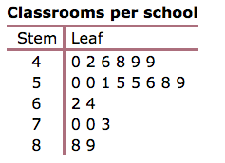

- Would you expect a large or a small standard deviation for the data? Explain your answer

- Calculate the Standard deviation?

10. [ 6 marks, 3, 1, 1, 1]
Mum and Lucy were having an argument about the number of hours she spends on facelook each night. They decided to record how many hours she spent on Facelook for one week. The results are shown below.

Day | Mon | Tues | Wed | Thurs | Fri | Sat | Sun
Hours on Facelook | 4 | 2 | 2 | 1 | 6 | 4 | 8

- Find the mode, median and mean for this data.

- Which of these measures could Mum use to demonstrate that Lucy spends too long on
Facelook?

- Which of these measures could Lucy use to show that she doesn’t spend too much time on Facelook?

- Which of the three measures is the best indication of the typical number of hours Lucy spends on Facelook a week.

11. [3 marks, 1, 2 ]
Complete the table below;

Score | Frequency | Score x frequency
1 | 5
2 | 10
3 | 4
4 | 7
5 | 8
6 | 3
7 | 9

- Calculate the mean score.

- Calculate the interquartile range.

